- Prolog program to sum the integers from 1 to n

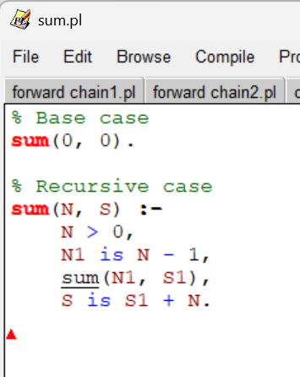

OUTPUT

- Prolog program for A DB with DOB

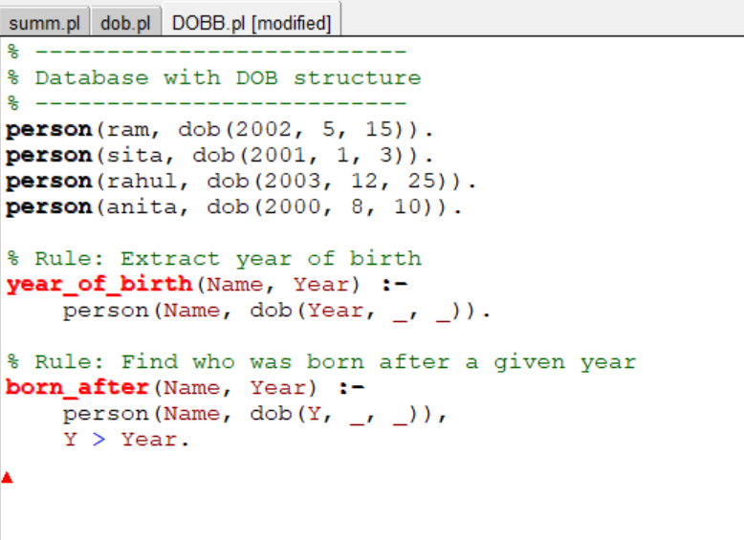

OUTPUT

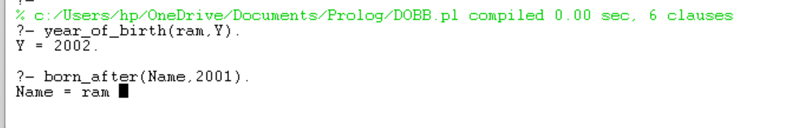

- Prolog program for student subcode

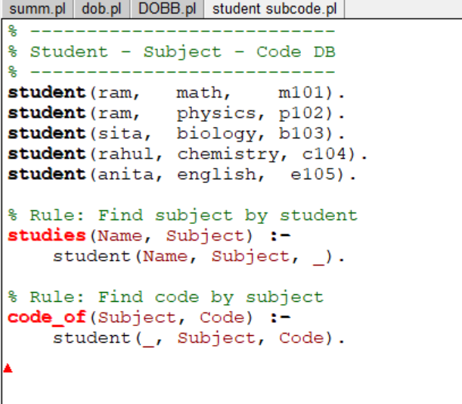

Output

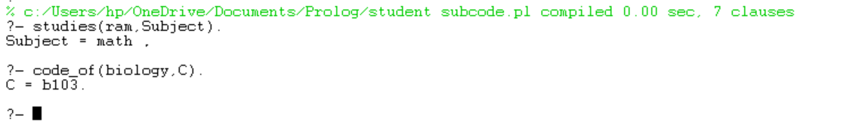

- Prolog programs for Planets DB

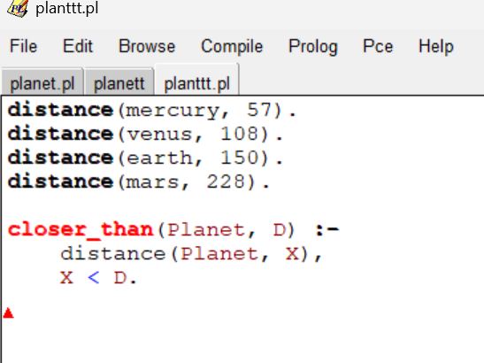

Output:

